RecipeGenius - Milestone II Design Document
Multi-Agent Workflow for a Cooking Assistant
Student: Ashriel Tayo | Course Project Deliverable
1. Purpose and Workflow Overview
RecipeGenius is a multi-agent cooking assistant that helps a user turn pantry ingredients into realistic meal recommendations while honoring dietary restrictions, serving size, and time limits. For Milestone II, the system uses a controller-led pipeline with a critique-and-revise loop. The workflow begins when the user submits pantry ingredients and preferences from the front-end. The controller then decomposes the request, routes subtasks to specialized agents, validates the result, and returns a structured recipe response with missing ingredients, substitutions, and a shopping list.
2. Coordination Mechanism
The coordination model is an orchestrated fixed pipeline with one feedback loop. The Controller Agent is the single coordination point. It receives the request, calls the Planner Agent to normalize the task, sends the structured task to the Recipe Finder Agent and Pantry Manager Agent, then passes the combined result to the Critic Agent. If the critic finds policy or quality issues, the controller revises the request or asks an upstream agent to regenerate output. The loop stops when the response is approved or the retry limit is reached.
3. Agent Roles and Input / Output Formats
Agent | Role | Input | Output | Failure Handling
Controller Agent | Orchestrates the workflow and manages retries | Raw user request from UI | Approved final response or retry | Catches exceptions, triggers revise loop, returns safe fallback
Planner Agent | Normalizes user goal into structured task fields | Pantry items, restriction, servings, time | Task plan object | Applies defaults and validates missing values
Recipe Finder Agent | Retrieves recipe candidate from API or local dataset | Task plan | Recipe object with name, ingredients, steps, tags | Retries with broadened constraints or cached data
Pantry Manager Agent | Compares pantry inventory to recipe ingredients | Task plan + recipe | Available items, missing items, substitutions | Uses substitution map and flags low pantry overlap
Shopping List Agent | Builds grouped grocery list and optional cost estimate | Missing ingredients + budget | Shopping list grouped by store section | Returns partial list if costs unavailable
Critic Agent | Verifies quality, consistency, and dietary compliance | Plan + recipe + pantry report | Approve / reject + issue list | Rejects bad output and provides reasons for revision
4. Communication Between Agents
Agents communicate through simple structured objects rather than free-form text. This keeps the workflow deterministic and easy to debug. The Planner produces a Plan object with normalized pantry items, dietary restriction, servings, and time limit. The Recipe Finder returns a Recipe object containing ingredients, steps, dietary tags, and cook time. The Pantry Manager returns a PantryReport with available ingredients, missing ingredients, and suggested substitutions. The Critic returns a VerificationResult with a Boolean approval flag and a list of issues. This message-passing approach makes it easier to test each stage independently and log the system state for troubleshooting.
5. Quality Control and Failure Handling
Quality control is handled by the Critic Agent and the Controller Agent together. The critic checks whether the recipe satisfies the selected dietary restriction, whether the recipe contains required fields, and whether it uses enough pantry items to stay relevant to the user request. If the critic rejects the candidate, the controller starts a limited revise loop. In the prototype, the first revision strategy is to relax the time limit slightly and re-run recipe retrieval. More advanced versions could switch data sources, adjust ingredient substitutions, or ask the front-end for one missing clarification. If retries fail, the controller returns a safe error message instead of an incomplete recommendation.
6. Tools, Data Sources, and Implementation Notes
The workflow is designed to work with the same project direction proposed earlier for RecipeGenius. The primary external tool is the Spoonacular API for recipe retrieval. Local persistence can be handled through SQLite for user preferences and pantry history, while a JSON or cached dictionary can store substitutions and fallback recipes. The attached Python implementation is an MVP version that uses an in-memory recipe catalog so the workflow can run without external dependencies during grading. In a production version, the Recipe Finder Agent would swap the local catalog for API calls while keeping the same input and output structure.
7. Deliverable Summary
This submission includes three Milestone II deliverables: (1) a high-resolution architecture diagram showing agents, tools, and dataflow; (2) this design document explaining the role of each agent, the coordination model, communication format, and failure handling; and (3) updated Python code implementing the multi-agent workflow with a controller-led pipeline and a critique-and-revise loop.

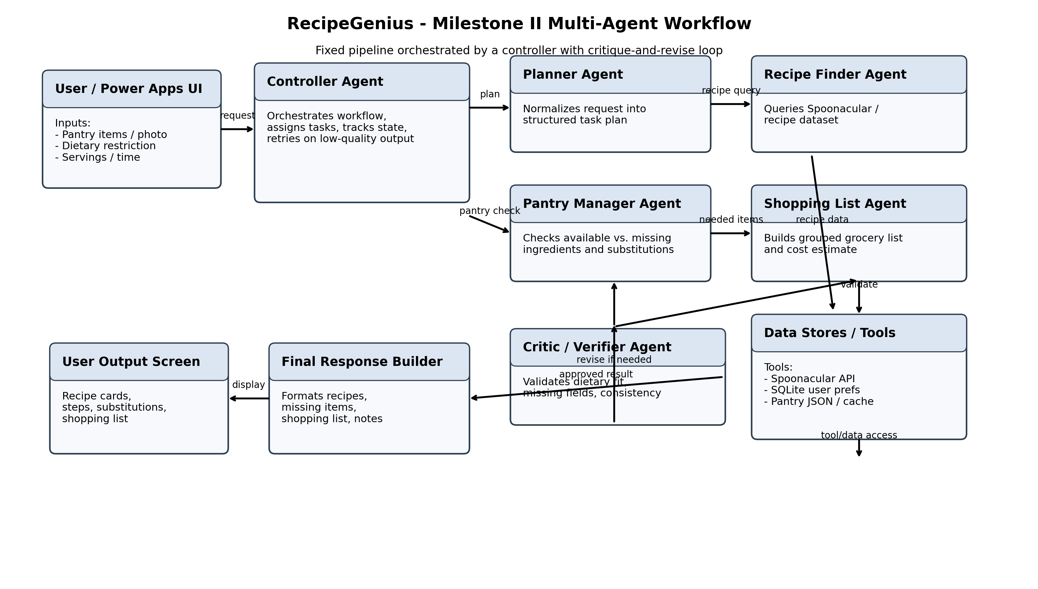
Figure 1. RecipeGenius multi-agent architecture.

